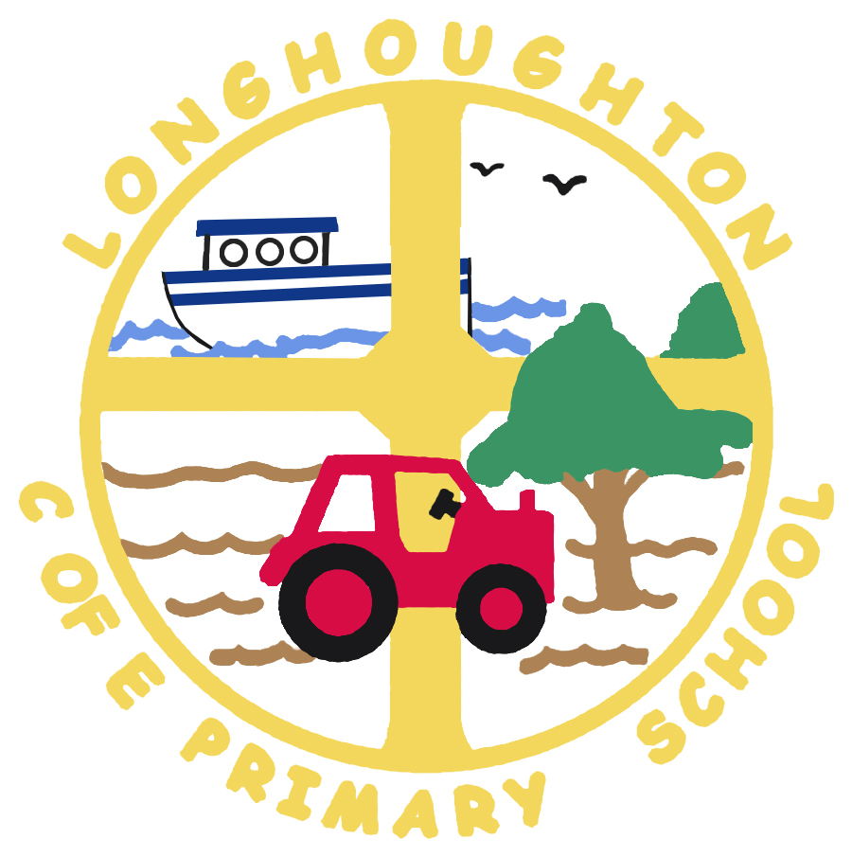

Longhoughton C of E Primary School
September 2017 Newsletter

I hope that you all had a good summer and that the children have been helpful!
It is lovely to see everyone back and ready to learn.

This is a brief newsletter to inform you of the meetings below, a full newsletter will follow soon.

Parent Meetings – Come and meet your child’s teacher!
The sessions detailed below will provide an opportunity for the class teachers to meet with parents collectively and talk about practises and procedures for the coming year (e.g. phonic work, reading maths, homework). There will also be the opportunity for parents to ask questions.

Monday 11th September | France Class and Egypt Class (Lower Key Stage 2)  Mrs Foy, Mrs Mortimer and Mrs Critchlow, 2:30pm in the school hall
Tuesday 12th September | Botswana Class (Year 1 & Year 2)  Mrs Sutcliffe, Mrs Johnston and Mrs Critchlow, 2:30pm, in the school hall
Monday 18th September | Brazil Class (Reception)  Mrs Whaley and Mrs Critchlow, 2:30pm, in the school hall
Tuesday 19th September | China Class (Upper Key Stage 2)  Mrs Hedley and Mrs Critchlow, 2:30pm, in the school hall

This newsletter can also be read on the school website – www.longhoughton.northumberland.sch.uk – through the ‘News & Events’ link on the Home page

