Newsletter

Botswana Class Summer term 2018

Dear Parents

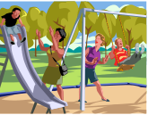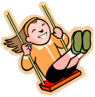
Our Local Area - Longhoughton
In Geography we will be learning about features of our local village environment; land use and key human features of the village eg Church, shops, school, and parks. We will use our mapping skills to see where key features are in relation to one another, we will use street maps and satellite maps to make observations. We will then make a map of the school grounds and label key features.
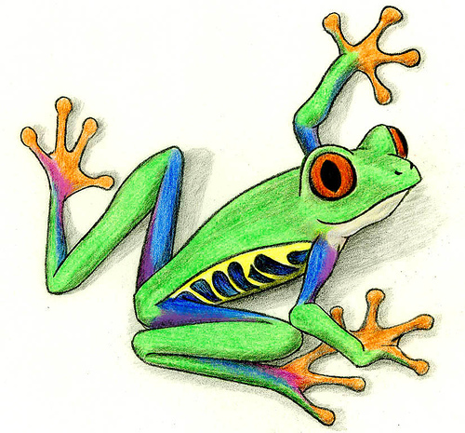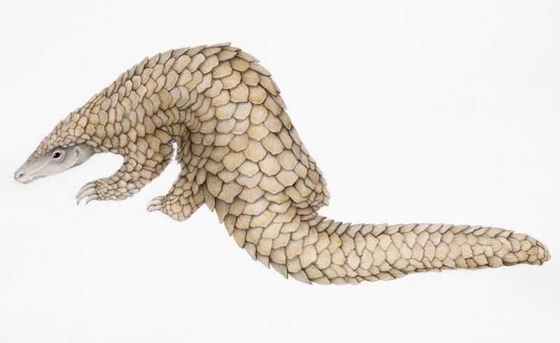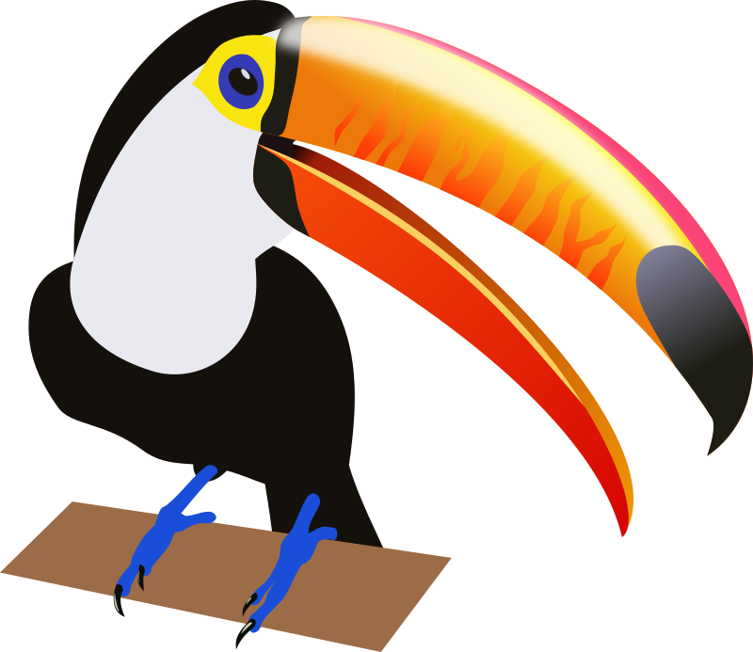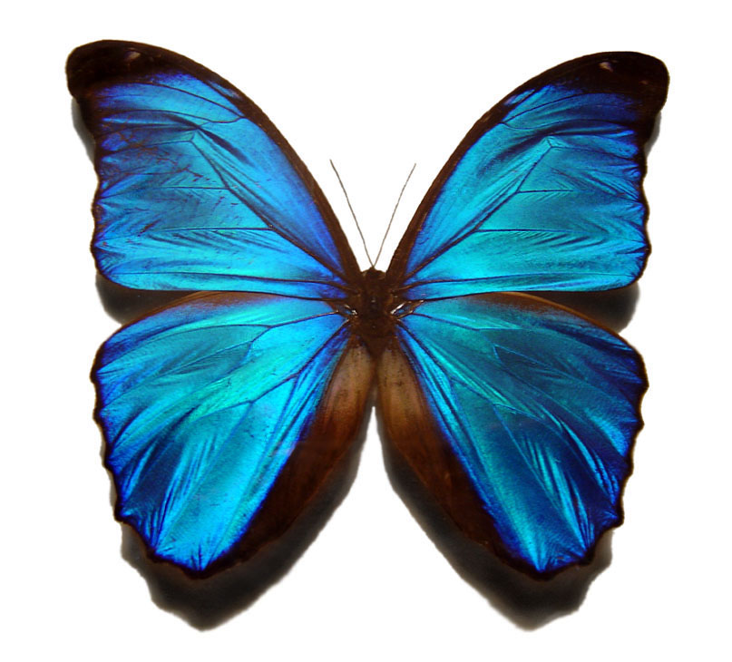
Science- Habitats
This term we will be learning about the different habitats around the world and the animals that have adapted to survive in those habitats. We will learn about the deserts, rainforests, temperate forests, the Arctic and Antarctic, the oceans and the amazing animals that live there.

In Literacy this term we will be reading and comparing stories by the same author. We have chosen Judith Kerr’s many stories about Mog the cat, and the Tiger who came to tea. We will be thinking about settings, plots and characters, humour and how events are linked within a story. In our non-fiction work will be linked with Science work about habitats. We will make an alphabetical text about animals in habitats. Finally we will be reading poetry, learning to recite poems and writing simple poetry with word patterns and rhyme.
In Maths we will be solving problems using all four number operations, we will use measures; mass, capacity, time and length and read different scales using standard units. We will continue to develop our calculation skills both written and mental, we will be interpreting data in graphs and charts, we will be learning how to use co-ordinates and linking this to geography work about our village.
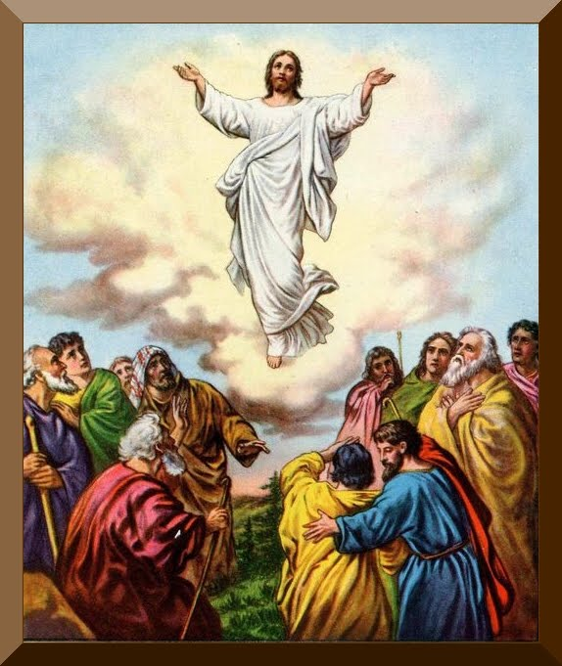
In RE we will be hearing the Bible stories about important Christian festivals of the Ascension and Pentecost and how these important events shaped the beginning of the Christian faith.
PE this half term will be Wednesday (Rugby) and Thursday. Children need to have PE kit in school at all times and this needs to include trainers and socks. Children without kit will have to miss their PE lesson.
The Year 2 children have survived the ‘Puzzle book ‘week! Many thanks to parents for their support in playing this down, there were no signs of stress in school and all the children worked very hard. You will receive the results in the School Report.
Many thanks
Mrs. Sutcliffe and Mrs Critchlow and Mrs Johnston

