Newsletter

India Class September 2018
Dear Parents
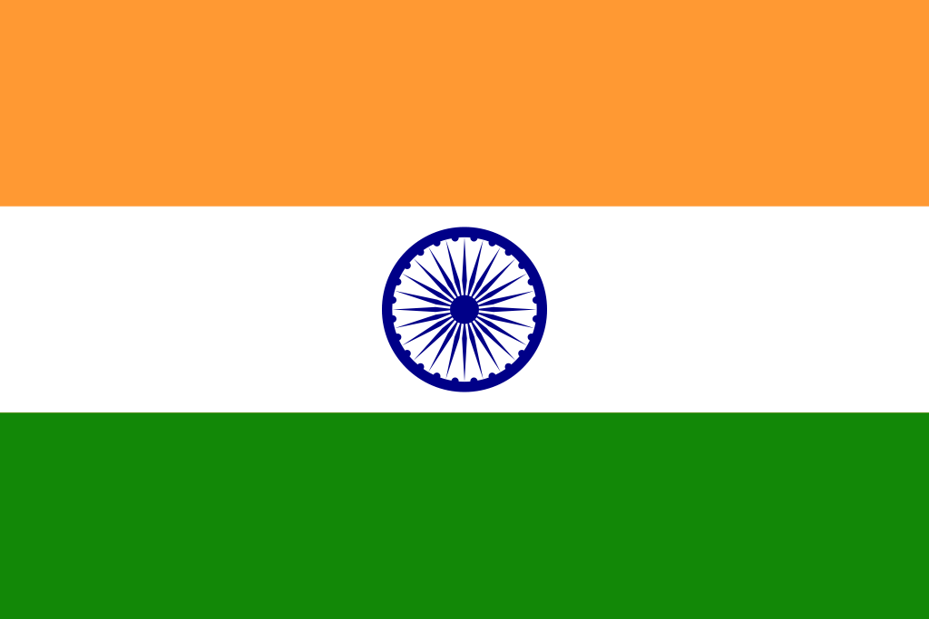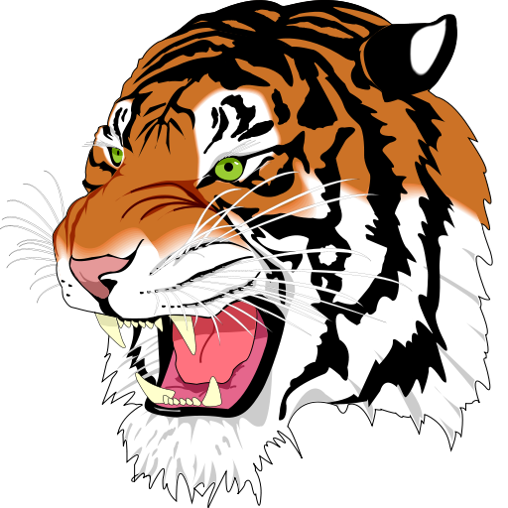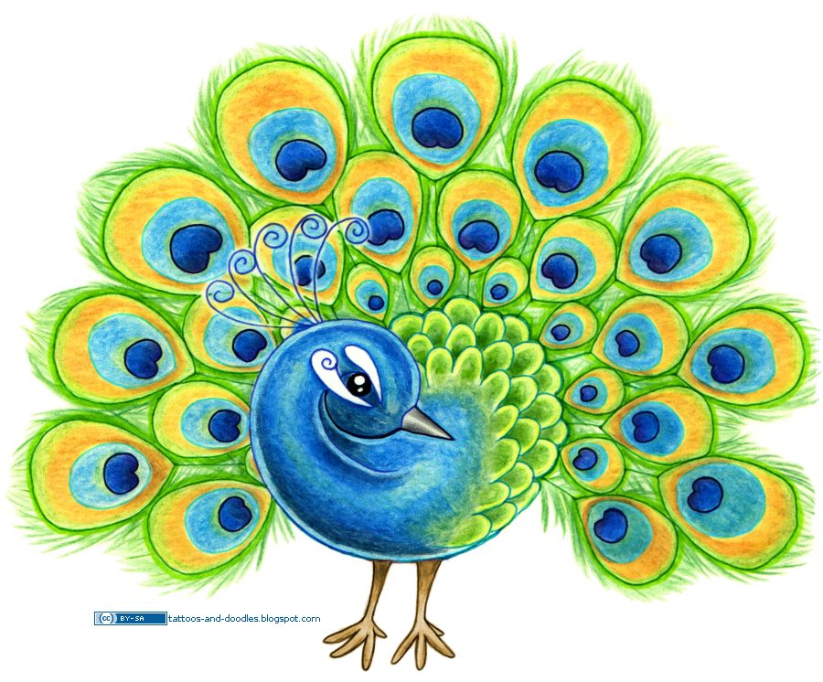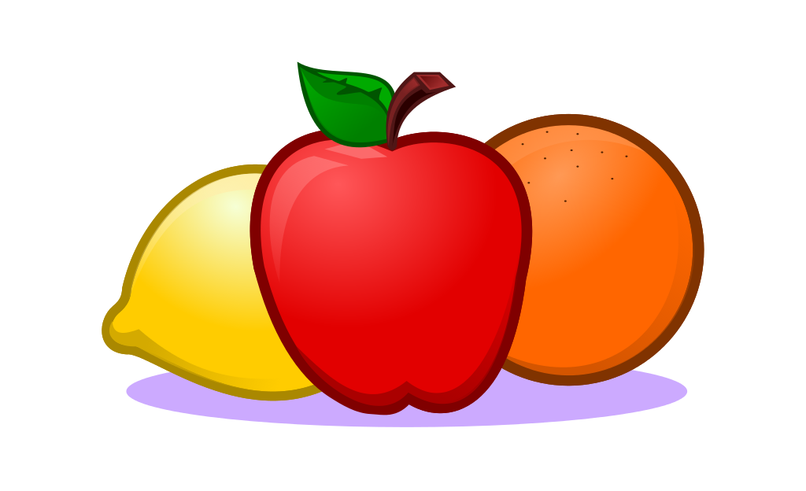
Our topics: India Health and growth
This half term we will be finding out about our class country, India. We will label maps and find India and its neighbouring countries in the continent of Asia. We will be thinking about the landscape from the Himalayas in the north, the desert areas in the west and the fertile lands where rice and tea are grown. We will discover which animals live in India including the national animal; the tiger. We will find out about the culture of its people: those that live in the cities and the towns and those who live in the villages in the countryside. We will learn to say some words in Hindi and hopefully some songs. We will be sewing an elephant, making Rangoli patterns, designing Mehndi hand patterns, tiger print patterns to name but a few. We will be cooking and eating an Indian feast of curry and rice and tasting naan bread, samosa, raita and mango juice.
In Science we shall also be finding out about how we can keep our bodies healthy. We will compare ourselves with other animals and living things and find out five things we must do to stay healthy and well. We will learn about food groups and how to plan a balanced and healthy meal. We will learn about how we grow from a baby and what skills we need to learn as we grow.
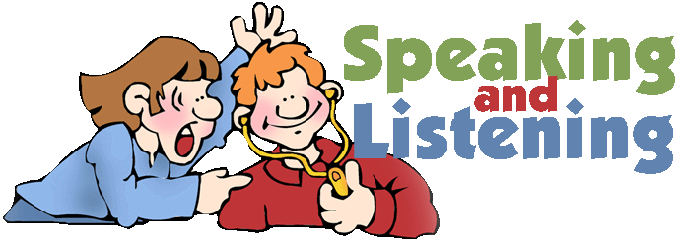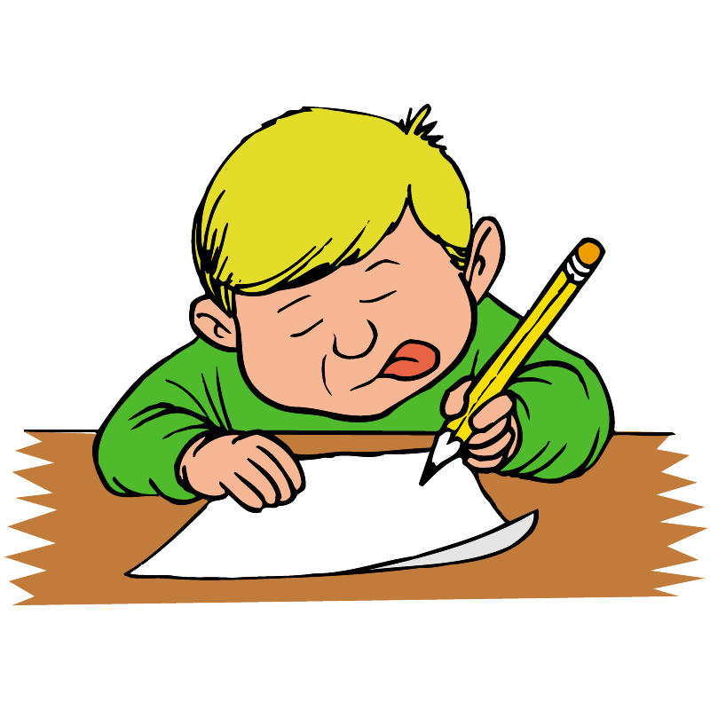
In Literacy we will begin the year by reading non-fiction reports about India and writing lists, captions and labels for our Passport Around the World book. Then we will be reading stories from India; thinking about the setting and characters and how events are linked in stories. We will be exploring poetry and learning to recite and perform some traditional and modern poetry. We will be reading and writing simple instructions using the appropriate features. We will continue our phonic work in our Read, Write Inc groups.

In Maths we will be developing our counting skills, counting numbers of objects in ones(Y1) and by grouping them in twos, fives and tens (y2), writing numbers as words, partitioning numbers into tens and ones, ordering numbers, completing number sequences including odd and even numbers. We will also work on calculations focusing on addition and subtraction skills and using and applying these to real-life situations including money. We will be developing our mental maths skills through the Big Maths programme in CLIC. Learn Its from Big Maths will be sent home for practising.

In RE we will be learning about what it means to belong to the Jewish faith. We will find out about the Synagogue, the Jewish place of worship, the Jewish scriptures in the Torah, about Shabbat the Jewish holy day and how it is celebrated. We are hoping to visit a Jewish Synagogue. The children will be encouraged to think about the Jewish faith and compare it with our own Christian faith and find similarities and differences.

Homework Thank you for your support with your child’s reading, just ten minutes reading a night really does make a huge difference to their progress. Year 2 children will be allowed to change their book after it has been read at home and the reading record has been signed by their parents. Year 1 children will have a new book on Monday and Thursday. Re-reading helps to develop vocabulary, confidence and gives more opportunity to retell and explore the text. Other homework will be sent home on Fridays (Some work can be completed in one session but spelling will need to be practised each night. Please return homework books and folders by Thursday morning.
PE- This half term –NUFC on Monday and Gymnastics on Wednesday.
India Class Worship – Wednesday 17 October ^{at} 9.15am.
Please do feel welcome to come and talk to us if there is something we should know that will help us support your child in school.
Many thanks
Mrs. Sutcliffe, Mrs Johnston and Mrs Critchlow

